Name: Hriday Kampani

Roll no: 2103080

Batch: C21

Experiment 7

**Aim:** Create a project schedule using Gantt Chart (MS Project)

**Theory:** A Gantt chart is a type of bar chart, adapted by Karol Adamiecki in 1896, and independently by Henry Gantt in the 1910s, that illustrates a project schedule. Gantt charts illustrate the start and finish dates of the terminal elements and summary elements of a project.

A Gantt chart allows the user to see:

* What the tasks are
* When each task begins and ends
* How long each task is scheduled to last
* Where tasks overlap with others and by how much • The start and end date of the entire project.

**Gantt chart represents following things :**

* All the tasks are listed at leftmost column.
* The horizontal bars indicate or represent required time by corresponding particular task.
* When occurring of multiple horizontal bars takes place at same time on calendar, then that means concurrency can be applied for performing particular tasks.
* The diamonds indicate milestones.

**Gantt Chart:**

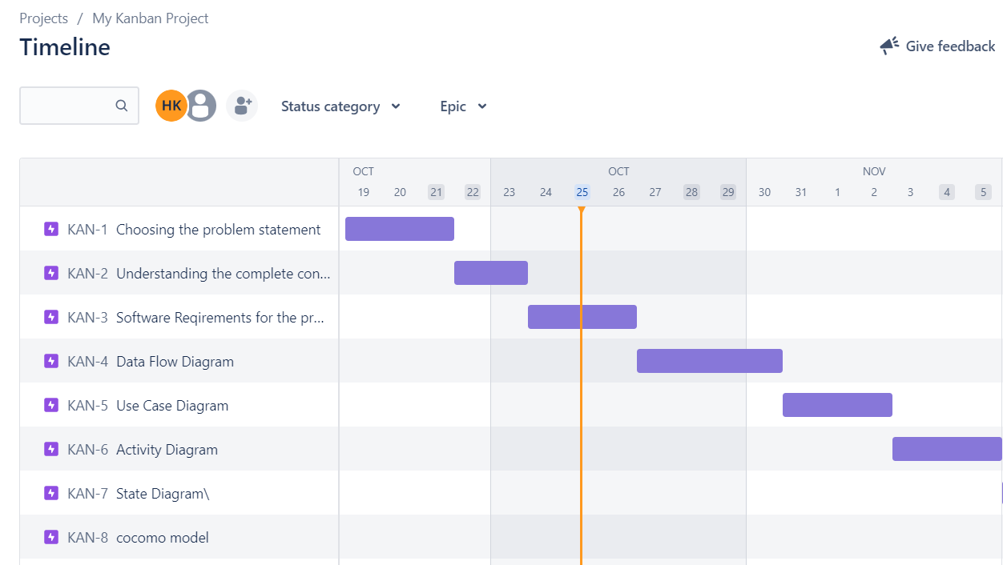

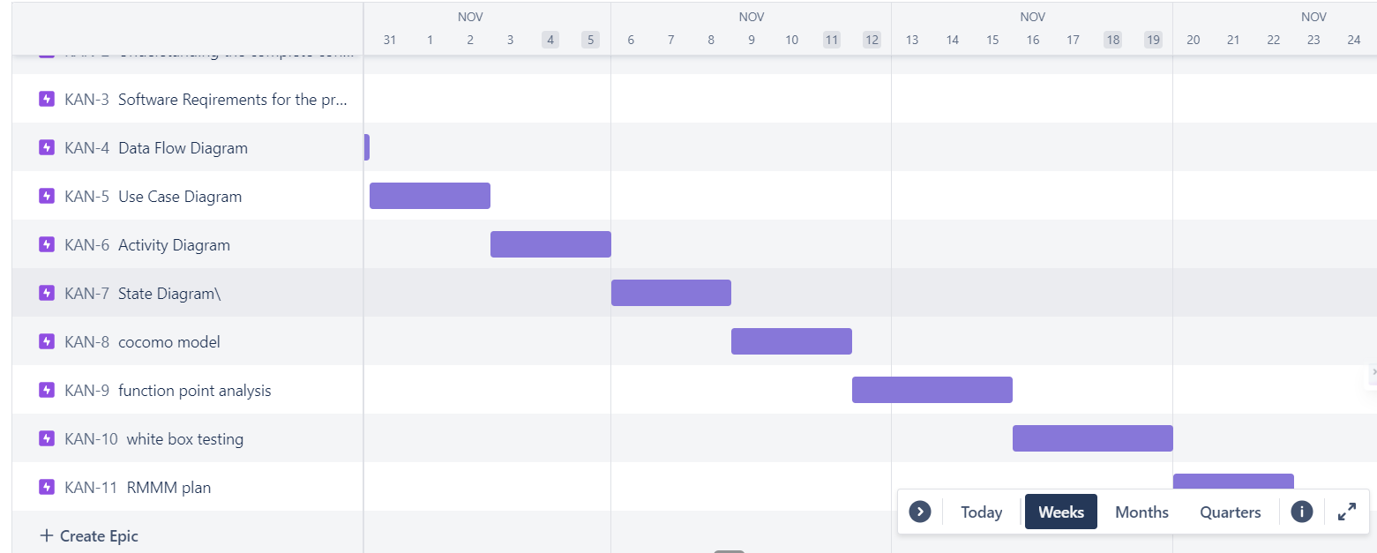

**Conclusion:**

Hence we have understood the creation of Gantt Chart for our project using JIRA software.

